**Module 9**

2. **For the Auto Dealership ERD shown in Figure 1, identify and resolve errors and note incompleteness in the specifications. Your solution should include a list of errors and a revised ERD.**

**Initial ER Diagram:**

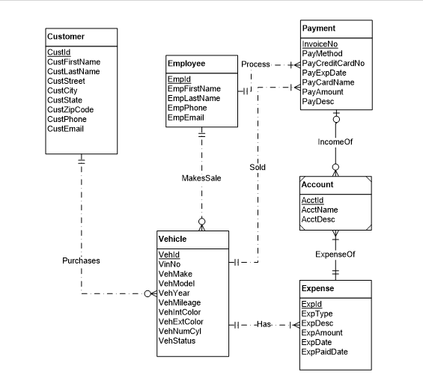

**List of Errors:**

1. Missing Attribute: The Vehicle Entity is not having attribute for Transmission Type(automatic or manual)
2. In MakeSale relationship between Employee and Vehicle, Minimum Cardinality near Employee should be zero as Vehicle Details can be recorded without an employee.
3. **Account** Should not be a weak entity.
4. **IncomeOf** Between Payment and Account should be (1,1) Near Account , and (Optional,mamy near Payment),it should be made non-identifying. (Reversed Relationship)
5. **ExpenseOf** Between Account and Expense should be (1,1) near Account and (Optional,Many near Expense),it should be made non-identifying.(Reversed Relationship)
6. **Sold cardinality** near Payment should be zero.Vehicle can remain for a lot of days before sale.
7. **Purchases cardinality** Should be zero near customer as vehicle is in stock for a lot of days before sales.
8. **Process** relationship between Employee and Payment does not mean anything.

